Instrument:
This data was collected using a Nicolet iS50 FT-IR (Thermo Scientific). (see lab manual for scan settings)

8 cm resolution spectra
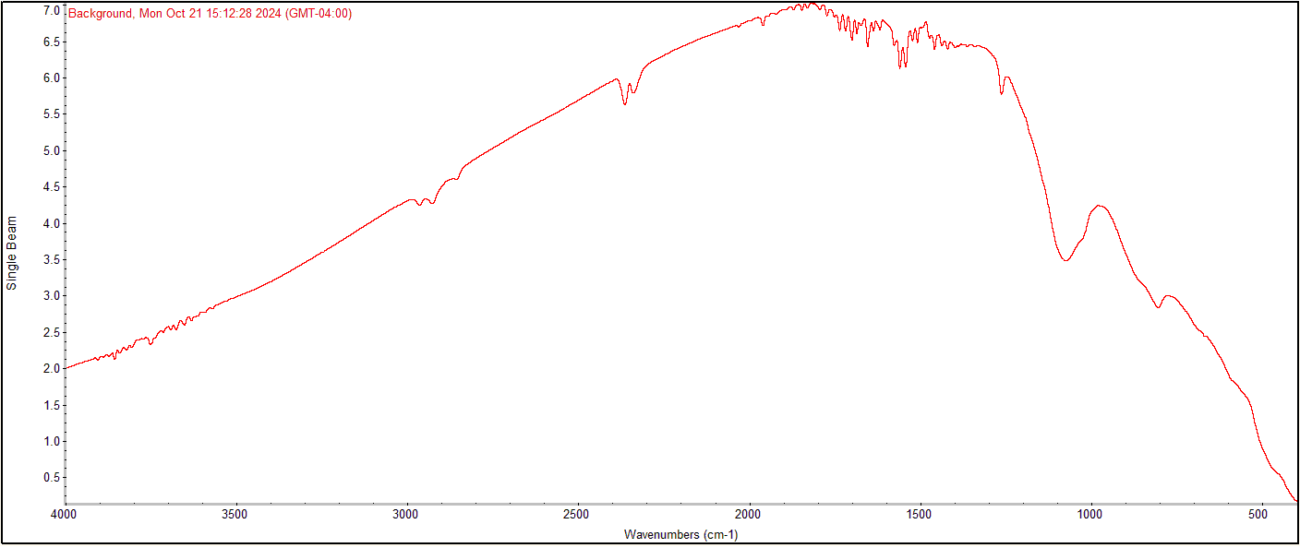
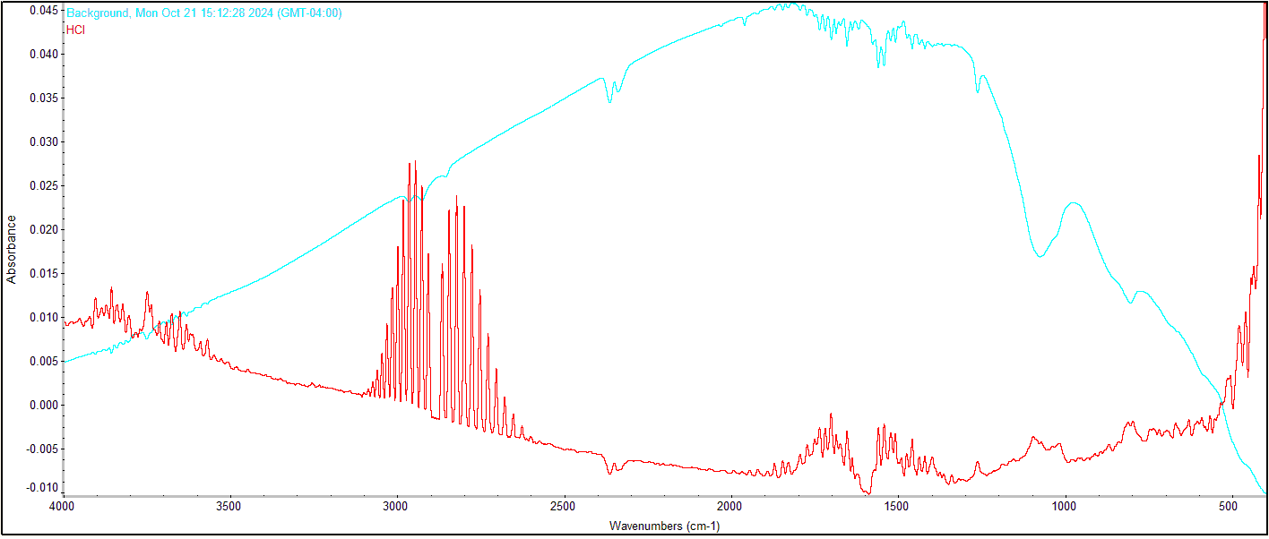
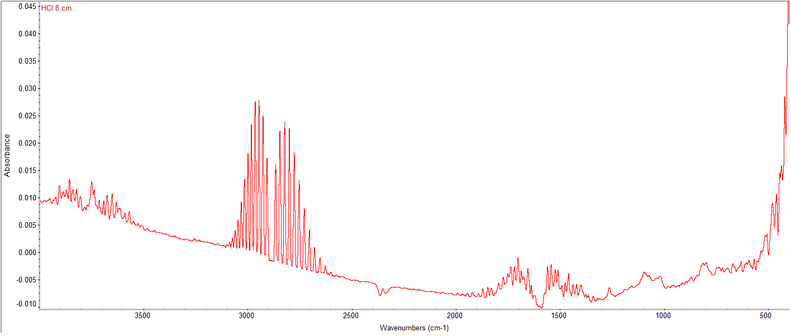
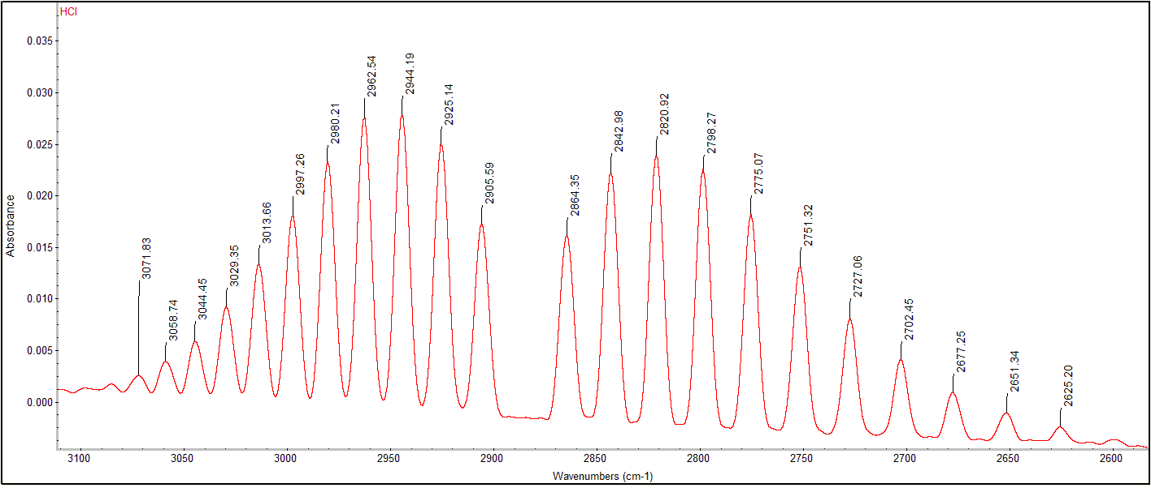

Peak Frequencies: *may be slightly different because the images above are from a different data set than the peaks below.

Tue Feb 04 14:50:04 2025 (GMT-05:00)
FIND PEAKS:
Spectrum: HCl
Region: 3244.03 2479.63
Absolute threshold: -0.0035
Sensitivity: 50
Peak list:
Position: 2625.20 Intensity: -0.0026
Position: 2651.34 Intensity: -0.0012
Position: 2677.25 Intensity: 0.00078
Position: 2702.45 Intensity: 0.0040
Position: 2727.06 Intensity: 0.0080
Position: 2751.32 Intensity: 0.0131
Position: 2775.07 Intensity: 0.0181
Position: 2798.27 Intensity: 0.0225
Position: 2820.92 Intensity: 0.0240
Position: 2842.98 Intensity: 0.0223
Position: 2864.35 Intensity: 0.0161
Position: 2905.59 Intensity: 0.0172
Position: 2925.14 Intensity: 0.0250
Position: 2944.19 Intensity: 0.0279
Position: 2962.54 Intensity: 0.0277
Position: 2980.21 Intensity: 0.0233
Position: 2997.26 Intensity: 0.0181
Position: 3013.66 Intensity: 0.0133
Position: 3029.35 Intensity: 0.0092
Position: 3044.45 Intensity: 0.0058
Position: 3058.74 Intensity: 0.0038
Position: 3071.83 Intensity: 0.0024

